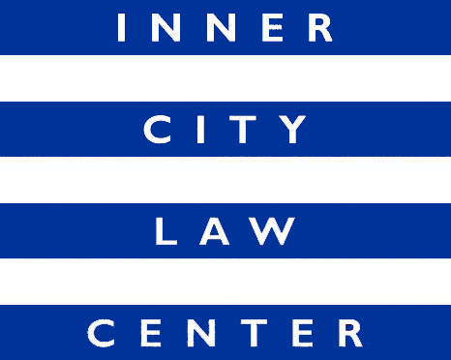

JOB ANNOUNCEMENT
Disability Benefits Staff Attorney or Senior Staff Attorney
(Full Time Position)

Inner City Law Center (ICLC) is a nonprofit law firm on Skid Row. We are looking for extraordinary people to help us end homelessness in Los Angeles. Founded on the fundamental principle that every person should always be treated with dignity and respect, ICLC fights for justice for low-income tenants, working-poor families, people living with disabilities or experiencing homelessness, people living with HIV/AIDS, and homeless veterans.

Position Description: This is an exciting opportunity for an attorney to join a groundbreaking project that positively impacts thousands of individuals in Los Angeles County each year. The attorney will focus on providing technical assistance to our primary partner (LA County Department of Health Services) and their staff on SSI, SSDI and CAPI (Cash Assistance Program for Immigrants) applications. The attorney will focus on legal reviews of applications for benefits, answering questions and providing guidance on initial eligibility rules, disability standards, and application preparation of SSI, SSDI, and CAPI benefits. The Attorney will be responsible for the creation and production of educational materials and tools to assist in continued Project improvement.

The attorney will work as part of a team and will share team responsibilities related to the Project, such as identifying systematic problems within the SSI/SSDI or CAPI application process and developing strategies to resolve them. This will likely include working directly with staff and leadership at the Social Security Administration and Department of Public Social Services in Los Angeles County.

The attorney will also carry a caseload of clients to represent in administrative hearings, in balance with the Technical Assistance duties. The attorney will be responsible for all aspects of representation on these cases, including meeting regularly with clients, reviewing medical records, and researching and writing hearing briefs. The attorney will be responsible for assigning work to and mentoring team paralegals on their cases. The attorney will collaborate with other team members in identifying systemic problems within the SSI/SSDI or CAPI administrative hearing systems. By gaining and developing skills in both training and capacity building activities and direct representation, this attorney will gain a wide range of experiences and expertise in one of the most fundamental and problematic pieces of the American social safety net.

Hiring Criteria: Commitment to ICLC’s mission and values. Ability to interact with a wide range of clients in a kind, appropriate, trauma-informed, and client-centered manner. Commitment to improving access to public benefits programs. Excellent oral and written communication skills. Organized and detail oriented. Ability to assume responsibility quickly and independently manage varied responsibilities. Ability to use good judgment, multitask, and meet deadlines. Membership in the California Bar or another State Bar is required.

This position will serve a nine-month probationary period. ICLC has a hybrid work environment with remote and onsite work available

Compensation: Salary range is $75,000 - $106,000, depending on experience. Excellent benefits.

How to Apply: Cover letters and resumes are reviewed upon receipt and applications will be accepted until the position is filled. To apply, please upload your resume and a cover letter detailing interest in the position directly at www.innercitylaw.org/join-our-team. Applications will not be considered if both resume and cover letter are not provided.

