03/08/2022

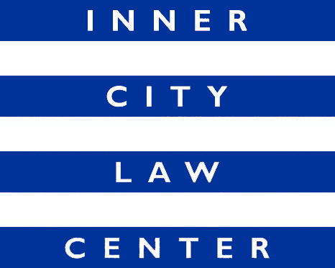
Job Announcement
CHIEF PROGRAM OFFICER
(Full-Time Position)

Inner City Law Center seeks a talented, dynamic, and creative Chief Program Officer to lead our efforts to end homelessness in Los Angeles. ICLC is a nonprofit, poverty-law firm located in the Skid Row neighborhood of Los Angeles. Founded on the fundamental principle that every person should always be treated with dignity and respect, ICLC’s 100+ staff and 500+ volunteers fight for housing justice for low-income tenants, working-poor families, people experiencing homelessness, people living with HIV/AIDS, people with disabilities, and homeless veterans.

For each of our clients, we ask, “What is the pathway to long-term stable housing?” Answering that question usually leads to legal representation that either directly addresses a housing challenge (e.g., defending an eviction or suing a slumlord) or that bolsters our client’s financial situation and enables them to better afford housing (e.g., connecting a client with VA or Social Security benefits).

ICLC’s Chief Program Officer oversees the Project Directors for the five ICLC teams that provide direct legal services to clients:

- ICLC’s Tenant Defense Team keeps families in their homes by defending low-income tenants facing eviction. This work involves fast-paced litigation in state court, including pleadings, discovery, motions, settlement negotiations, trials, and appeals.
- ICLC’s Benefits Advocacy Team connects people living with disabilities with public benefits. This work involves assisting individuals who are experiencing homelessness gain access to critical social security and other disability benefits by either providing technical assistance, training, and other support, or by representing clients in disability establishment hearings and appeals.
- ICLC’s Homeless Veterans Team connects homeless veterans with VA benefits. This work involves helping homeless veterans with disabilities upgrade their military discharge status and navigate a complex VA benefits system.
- ICLC’s Housing Litigation Team sues slumlords to force them to fix up their buildings and pay damages to tenants. This work involves tenant organizing as well as complex civil litigation in state court, including pleadings, discovery, motions, settlement negotiations, trials, and appeals.
- ICLC’s Preventing and Ending Homelessness Team removes other legal barriers to housing for people who are experiencing homelessness or at imminent risk of homelessness. This work involves addressing whatever other legal barriers might exist to housing stability for our clients, including clearing citations and tickets, expunging criminal records, addressing reasonable accommodation issues, tackling credit/debt issues, and helping clients obtain identification documents or public benefits.

The Chief Program Officer reports directly to the Chief Executive Officer and has primary responsibility for ensuring high-quality, ethical, culturally-conscious, and client-centered legal representation consistent with ICLC’s values, vision and strategic goals. This includes:
- Supporting Project Directors with managing caseloads, developing and managing budgets, defining expectations, ensuring effective case management, accurate record-keeping and reporting of results and client outcomes, as well as developing and retaining high-performing staff.
- Ensuring a healthy, work environment that promotes professional development, open communication, and accountability.
- Partnering with other senior staff to identify and pursue funding and partnership opportunities.
- Partnering with ICLC’s Pro Bono Director to develop relationships with pro bono counsel at some of the highest-profile law firms in the city and with Project Directors to effectively leverage pro bono resources.
- Helping Project Directors, the General Counsel, and other staff to navigate legal ethics questions as they arise.
- Serving as ICLC’s ambassador to community organizations and government agencies.
- Supporting ICLC’s Policy Advocacy Team’s efforts to promote policy changes that reduce systemic barriers to safe and affordable housing.
- Performing other duties as needed.

Required Hiring Criteria: Commitment to ICLC’s mission and values. Strong management and leadership skills. At least ten years’ experience as a practicing attorney. Membership in the California Bar is required, unless you are currently awaiting bar results or are eligible to practice as a Registered Legal Aid Attorney under Rule 9.45 of the California Rules of Court. Demonstrated ability to supervise, motivate, and lead teams. Innovative and solution-oriented. Excellent oral and written communication skills. Ability to interact with a wide range of people in a kind and professional manner. Demonstrated understanding of issues affecting low-income communities and communities of color.

Compensation: Salary commensurate with qualifications and experience (in the range of $130,000 to $170,000). Excellent benefits.

How to Apply: Cover letters and resumes are reviewed upon receipt and applications will be accepted until the position is filled. To apply, please upload your resume and a cover letter detailing interest in the position directly at https://innercitylaw.org/join-our-team/.

