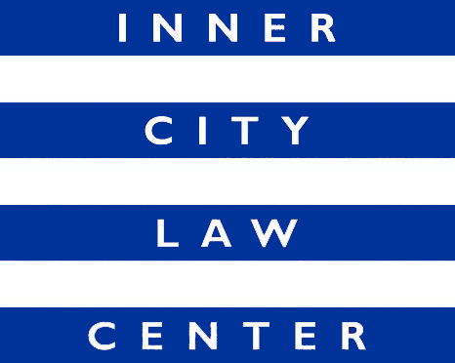

JOB ANNOUNCEMENT

Staff Attorney
Slum Housing Litigation
(Full-Time Position)

Inner City Law Center (ICLC) is a nonprofit law firm on Skid Row. We are looking for extraordinary people to help us end homelessness in Los Angeles. Founded on the fundamental principle that every person should always be treated with dignity and respect, ICLC fights for justice for low-income tenants, working-poor families, people who have disabilities or are experiencing homelessness, people living with HIV/AIDS, and homeless veterans.

Position Description: ICLC is seeking a full-time Staff Attorney with at least two years of litigation experience to join our team and work on habitability litigation on behalf of low-income tenants. This position is part of ICLC’s Slum Housing Litigation Team, which combines outreach, education, tenant organizing, and litigation to address housing-related health hazards that threaten vulnerable, low-income tenants. ICLC’s lawyers, paralegals, and organizers seek to improve unhealthy living conditions, preserve affordable housing, protect against retaliation, and recover financial damages.

The Staff Attorney will support litigation against landlords who rent unsafe and unhealthy apartments to vulnerable low-income tenants. The tasks include new client intakes, drafting pleadings and discovery, responding to discovery, motions and oppositions to motions, document summaries, witness files, depositions, mediations, trials, and all other tasks as needed to support ongoing litigation.

Hiring Criteria: Commitment to ICLC’s mission and values. Litigation experience. Excellent oral and written communication skills. Ability to assume responsibility quickly and ability to work closely with a team including the Director of Litigation, staff attorneys, paralegals, organizers and administrative personnel. Ability to use good judgment, multi-task, and meet deadlines. Demonstrated commitment to working with low-income communities. Membership in the California Bar or another State Bar is required. Must use and conform to in house systems and practices and compliance with deadlines. This position will serve a nine-month probationary period.

Compensation: Salary starts at $79,500 for a third-year attorney and increases depending on experience. Excellent benefits.

How to Apply: Cover letters and resumes are reviewed upon receipt and applications will be accepted until the position is filled. To apply, please upload your resume and a cover letter detailing interest in the position directly at https://innercitylaw.org/join-our-team/.

