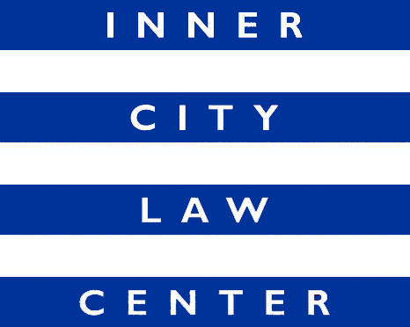

JOB ANNOUNCEMENT
Supervising Attorney
Bringing Families Home Project
(Full Time Position)

Inner City Law Center (ICLC) is a nonprofit law firm in Skid Row in Downtown Los Angeles. We are looking for extraordinary people to help us end homelessness in Los Angeles. Founded on the fundamental principle that every person should always be treated with dignity and respect, ICLC fights for justice for low-income tenants, working-poor families, people experiencing homelessness, people living with HIV/AIDS, people with disabilities, and homeless veterans.

Position Description: The Supervising Attorney of Bringing Families Home will serve clients who are experiencing or are at risk of homelessness and receiving child welfare services; these clients may be experiencing family separation and working towards family reunification. Working in partnership with homeless services, other community service providers, and the project funder, the Supervising Attorney will provide holistic legal services to tackle barriers to our clients becoming and staying housed and related barriers that impact family stability. This focus on providing housing stability and related legal services to vulnerable families fits perfectly with the question that ICLC asks for each of our clients: “What is the pathway to long-term stable housing for this individual or family?”

Responsibilities:
- Help shape a newly funded project and manage a team of two attorneys and one paralegal.
- Develop and maintain strong relationships with funder, legal services partner, and five Bringing Families Home homeless prevention contractors.
- Help refine a “total legal health checkup” assessment tool to ensure that our advocates are asking potential clients the right questions to evaluate how we can best help them.
- Refine case acceptance criteria and a streamlined referral process to other providers so that clients experience a “no wrong door” approach.
- Provide holistic legal services to tackle barriers that our clients face and carry caseload.
- Supervise, mentor and guide attorneys and paralegals with creative problem solving and litigation to address novel issues.
- Be comfortable with helping to guide your team in addressing a wide-array of legal issues.
- Participate in community outreach events, including monthly in-person legal intake clinics, and develop relationships with service providers.
- Perform management roles, including organizing team work-flow and work schedules, assigning work, providing substantive supervision of legal work, managing aspects of grant funding, providing professional development opportunities for staff, and providing guidance and recommendations regarding hiring, promotion, evaluations, and significant discipline decisions.
- Partner with pro bono counsel to expand the volume of services ICLC can provide.
- Other duties as assigned.

Hiring Criteria: Commitment to ICLC’s mission. Organized, detail oriented, and able to assume responsibility quickly and independently in a rapidly growing organization. Ability to learn new areas of law. Ability to use good judgment. Excellent oral and written communication skills. Active Bar Membership in California, or another state; ability to get registered under Registered Legal Services Program. A minimum of six years of experience of poverty law experience. Access to reliable transportation to get to various courthouses across Los Angeles County.

Compensation: Salary range is $92,250 – $118,000, depending on experience. Excellent benefits.

How to Apply: Cover letters and resumes are reviewed upon receipt and applications will be accepted until the position is filled. To apply, please upload your resume and a cover letter detailing interest in the position directly at www.innercitylaw.org/join-our-team.

